

Excel is an analytical tool used to analyze and save data. With Excel, users can import data from any database and explore the explanatory and visualization features of the tool.

This report gives a detailed description of the analysis process of the Flipkart mobiles dataset, with the dataset downloaded in CSV format from the Kaggle website.

The dataset contains specs of various mobile brands in India, which have been scraped from the Ecommerce website "Flipkart." This dataset contains 3114 rows and 8 columns. Below are the column names and what they represent:

**Brand**: Name of the mobile manufacturer

**Model**: Model number of the mobile phone

**Color**: Color of the model

**Memory:** RAM of the model (4GB, 6GB, 8GB).

**Storage**: ROM of the model (32GB, 64GB, 128GB, 256GB).

**Rating**: Rating of the model based on reviews (out of 5).

**Selling price**: Selling price/discounted price of the model in INR when this data was scraped.

**Original price**: Actual price of the model in INR.

## Data cleaning

Data cleaning is important as it helps increase overall productivity and allows for high-quality information in the decision-making process. Some of the steps I took are the following:

* I created two columns for the original price in USD and the selling price in USD by converting INR to USD. I did this by dividing the INR by 82.75 because, as of the time of the data cleaning, 82.75 INR was equal to 1 USD.
* I also added a column "discounted price," where I subtracted the original price from the selling price to let me know the profit.
* Then I removed the duplicate values—109 duplicate values—so 3006 rows and 9 columns remained.

**Using the pivot table and dashboard, I could answer the following question**s:

* Different price range segments for mobiles in India.
* Brand with most product offerings for the Indian market.
* Most common specs offered by various brands (e.g., if all brands more commonly offer the 4 GB memory and 64GB storage models).
* Most commonly offered colors by all brands.
* The brand that has the highest discounted price.

## **Conclusion**

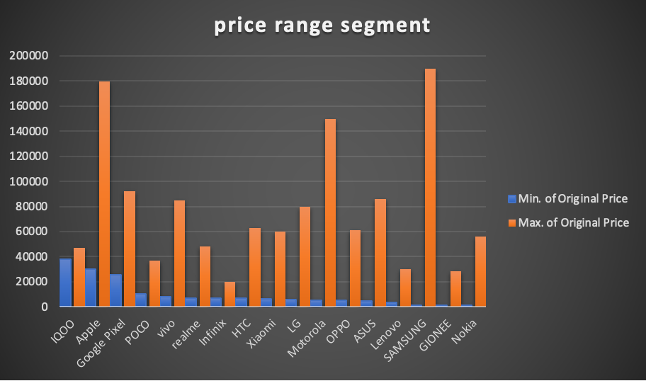

Samsung has the highest price range segment from 1,099–189,999 INR; Apple has the second to the highest price range of 29,900–179,900 INR; and Xiaomi has the lowest price range which is between 6,499–59,999 INR.

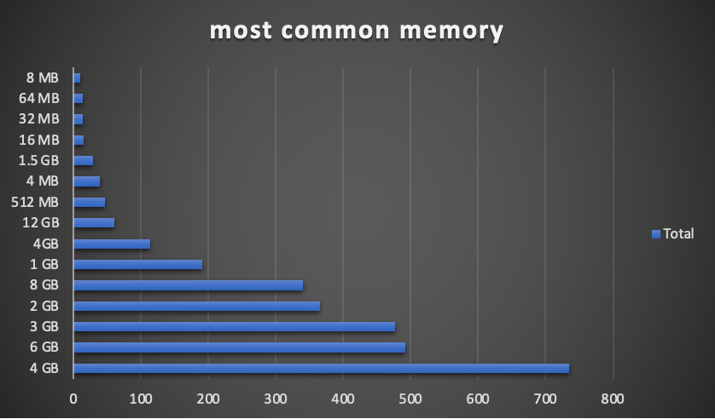

From the dataset, Samsung has the highest number of product models in India, which is 207, seconded by Nokia with 83 product models. Also, 4GB is the most memory storage offered in the Indian market with 739 products, followed by 6GB with 499 products.

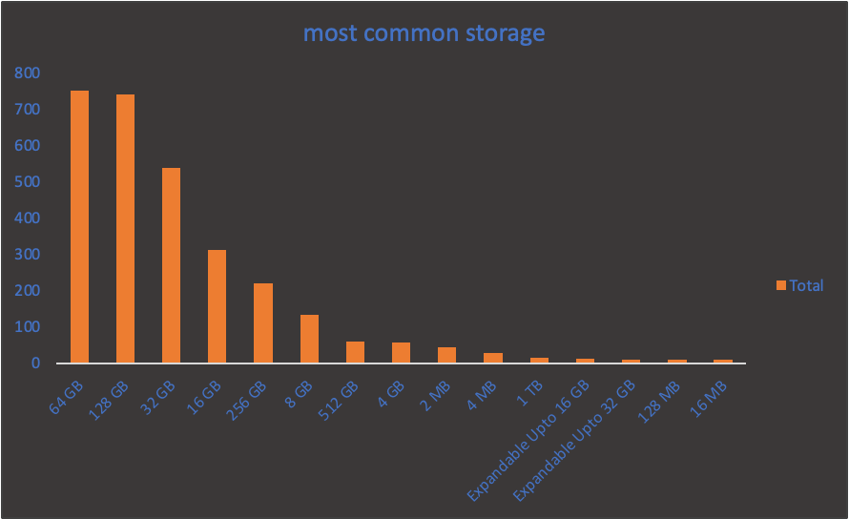

The most commonly offered storage space option is 64GB with 750 product models, follow by 128GB with 741 product models.

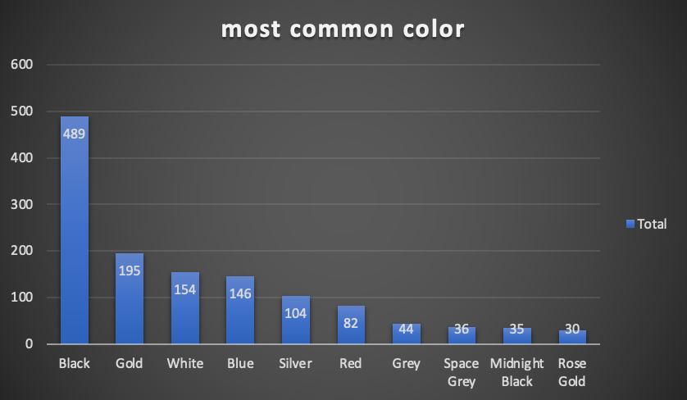Black is the most common color offered by most brands followed by gold and white.

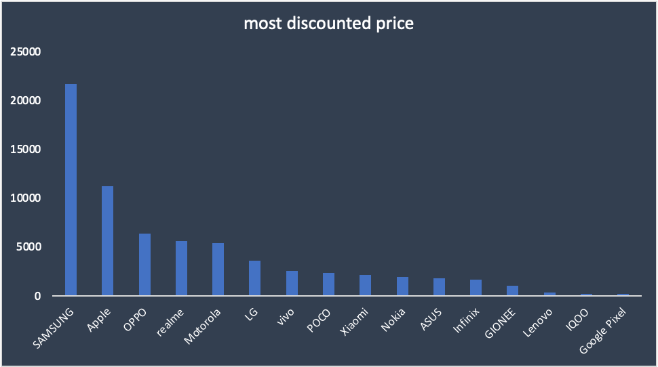

Samsung has the highest discounted price (profit) at 1795057 INR for the sum total of all the phones (Selling Price - Original Price), whereas HTC has zero discounted price.



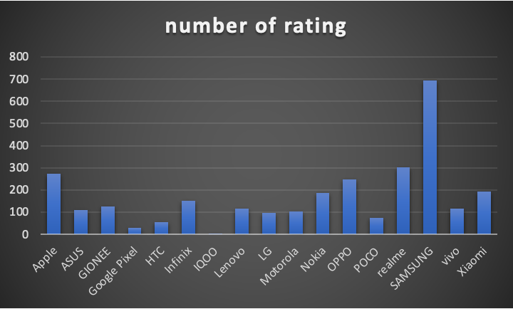

From the dataset, Samsung is the most-rated mobile phone in India with a rating of 694, followed by Apple, with a rating of 272. IQOO is the least-rated mobile phone with a rating of only 5.